PROJECT REPORT

US PNEUMONIA & INFLUENZA MORTALITY RATES (2018–2025)

Submitted by:
ANURAG NEPAL
SAN FRANCISCO,CALIFORNIA

Submitted for
MATH 443
TIME SERIES ANALYSIS
FALL 2024

ABSTRACT

This project investigates the mortality dynamics of Pneumonia and Influenza (P&I) in the United States from 2018 to 2025, with a primary focus on navigating the statistical volatility introduced by the COVID-19 pandemic. Using monthly aggregated CDC mortality data, we implemented a time-series modeling pipeline involving outlier interpolation, seasonal decomposition (STL), and stationary testing. We evaluated multiple forecasting frameworks, including ARIMA, ETS, and GARCH models. The findings reveal that a Log-Transformed Seasonal ARIMA(1,1,1) (2,1,0)[12] model on cleaned data provides the most robust fit (AICc: 96.64, RMSE: 1.0127). The results indicate a return to historical seasonal patterns, with projected mortality peaks of 7–8% during the 2026 and 2027 winter seasons. Furthermore, a hybrid ARIMA-GARCH approach successfully captured conditional volatility, offering refined confidence intervals for public health preparedness. This project underscores the necessity of data cleaning in post-pandemic health informatics and provides a 24-month predictive baseline for healthcare resource allocation.

TABLE OF CONTENTS

ABSTRACT ii
TABLE OF CONTENTS ii
TABLE OF FIGURES iii
INDIVIDUAL WORK Error! Bookmark not defined.
1.1 Background and Motivation Error! Bookmark not defined.
1.2 Goal and Specifications Error! Bookmark not defined.
1.3 Design Error! Bookmark not defined.
1.3.1 Infection Mask Segmentation Error! Bookmark not defined.
1.3.2 Lung Mask Segmentation Error! Bookmark not defined.
1.3.3 Infection Quantification Error! Bookmark not defined.
1.4 Implementation Error! Bookmark not defined.
1.5 Performance Evaluation Error! Bookmark not defined.
1.6 Technical Challenges 17
WORK DONE BY THE GROUP 18
2.1 Motivation and Goal 18
2.2 Design of Overall System 18
2.3 Individual Assignments 19
CONCLUSION 20
REFERENCES 21

TABLE OF FIGURES
Figure 1 CT Scan of Lungs with COVID-19 Infection Error! Bookmark not defined.
Figure 2 System Design Error! Bookmark not defined.
Figure 3 Infection Mask Error! Bookmark not defined.
Figure 4 Lung Mask Error! Bookmark not defined.
Figure 5 Annotated vs Segmented Metrics 17
Figure 6 Over segmented Infection Mask 17
Figure 7 Watershed Algorithm Issues 18
Figure 8 Overall Design 18

Introduction
Pneumonia and Influenza (P&I) represent a persistent and significant burden on the United States healthcare system. These respiratory conditions are characterized by a highly predictable seasonal cycle, typically peaking during the winter months when environmental conditions and human behavior favor viral transmission. However, the period between 2020 and 2023 presented an unprecedented challenge to traditional time-series forecasting. The emergence of COVID-19 not only directy impacted mortality rates but also disrupted the standard reporting and transmission patterns of seasonal influenza. This project seeks to analyze the P&I mortality landscape through this volatile period to establish a reliable baseline for the upcoming 2026 and 2027 seasons.
The primary motivation for this project stems from the need for accurate public health forecasting in a "post-pandemic" context. Traditional models trained on raw data from the pandemic years often fail because they treat one-time pandemic surges as recurring seasonal events, leading to massive over-predictions. The objective of this project is to successfully separate the pandemic "noise" from the seasonal influenza "signal." By doing so, we aim to provide a 24-month forecast that assists hospital administrators and public health officials in predicting staffing needs and bed capacity requirements. Specifically, the project evaluates the effectiveness of data cleaning and transformation techniques in restoring the predictive power of univariate time-series models.

Data Description and Exploration

The dataset utilized in this project consists of weekly mortality counts from the CDC’s National Center for Health Statistics (NCHS), aggregated to a monthly level for stability. The target variable is the "Percent P&I," calculated as the sum of influenza and pneumonia deaths divided by the total deaths from all causes. This percentage-based approach is superior to raw counts because it automatically controls for fluctuations in the total population and overall mortality trends. Initial exploratory analysis via a raw time-series plot revealed a mean mortality rate of 7.69 percent, but with extreme volatility. The maximum reached 18.97 percent during the pandemic, which was nearly triple the summer troughs of 5.15 percent.

Table 1 Data Summary Statistics
Min. | 5.150
1st Qu. | 5.768
Median | 6.437
Mean | 7.687
3rd Qu. | 8.395
Max. | 18.968

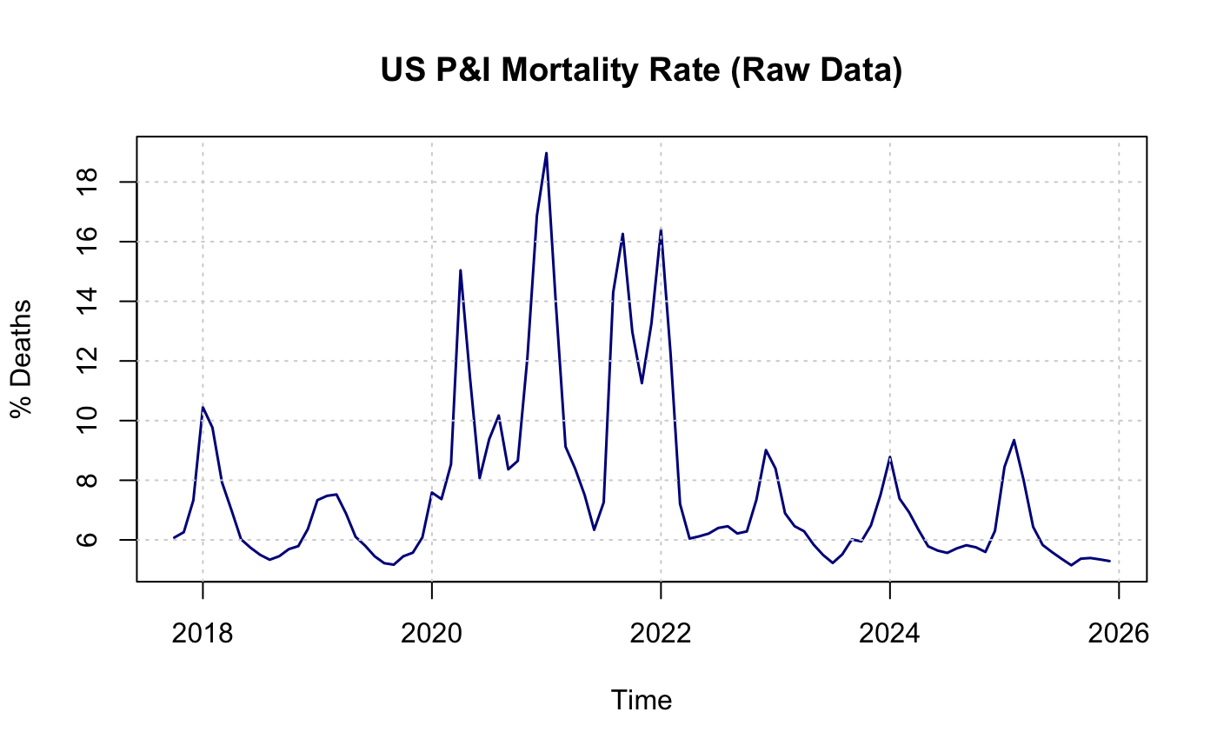
Figure 1 Raw Data
I utilized the tsclean() algorithm, which employs seasonal decomposition to identify outliers, particularly the massive COVID-19 spikes, and replaces them with linearly interpolated values. This process is essential because outliers can disproportionately influence the Autoregressive (AR) and Moving Average (MA) coefficients in an ARIMA model.

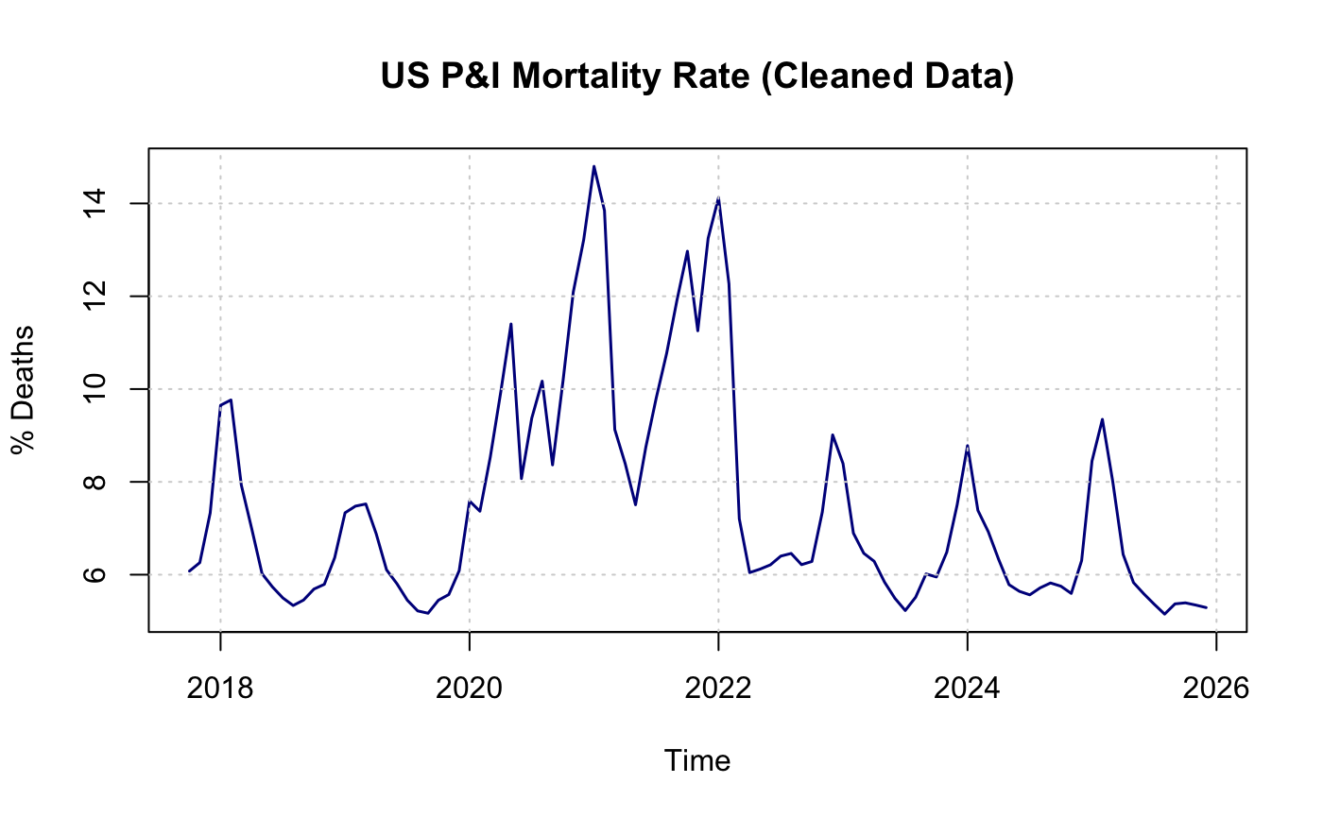
Figure 2 Cleaned Data
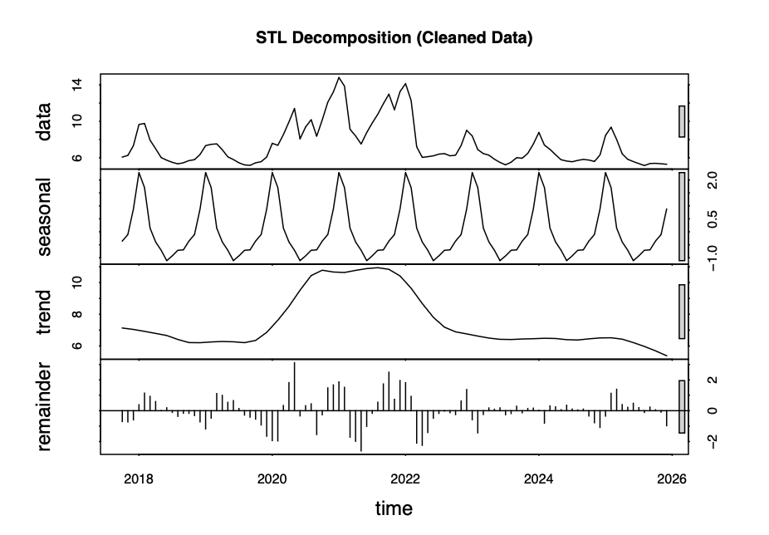
Figure 3 STL Decomposition
To further explore the structure of the cleaned data, I applied Seasonal-Trend decomposition using STL. This STL plot clearly separated the data into a highly regular 12-month seasonal component, a fluctuating trend, and a remainder component. The regularity observed in the seasonal component confirmed that seasonal differencing is required for the series to reach stationarity.

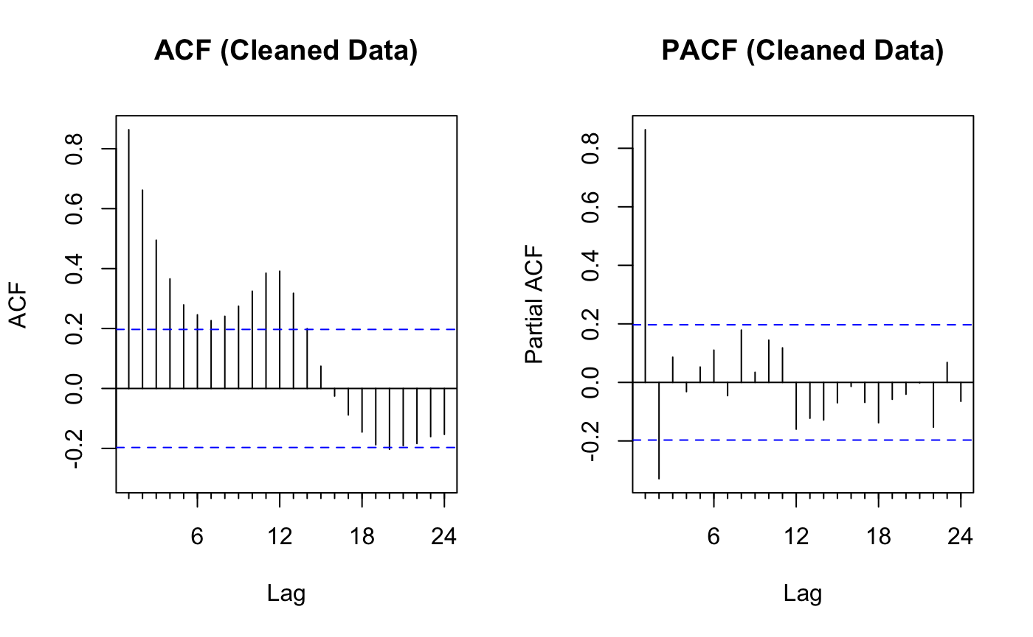
Figure 4 ACF and PACF
To determine the mathematical structure of the potential models, I analyzed the Autocorrelation Function (ACF) and Partial Autocorrelation Function (PACF) plots. The ACF plot for the cleaned data showed significant, repeating spikes at lags 12, 24, and 36, which provided conclusive evidence of a strong annual seasonal cycle. These spikes remained significant across many lags, suggesting that the seasonal component was non-stationary and required differencing. The PACF plot showed a sharp cutoff after the first two lags, suggesting that an Autoregressive (AR) process of order one or two should be appropriate for capturing the non-seasonal dependencies.

Methodology

ADF Test
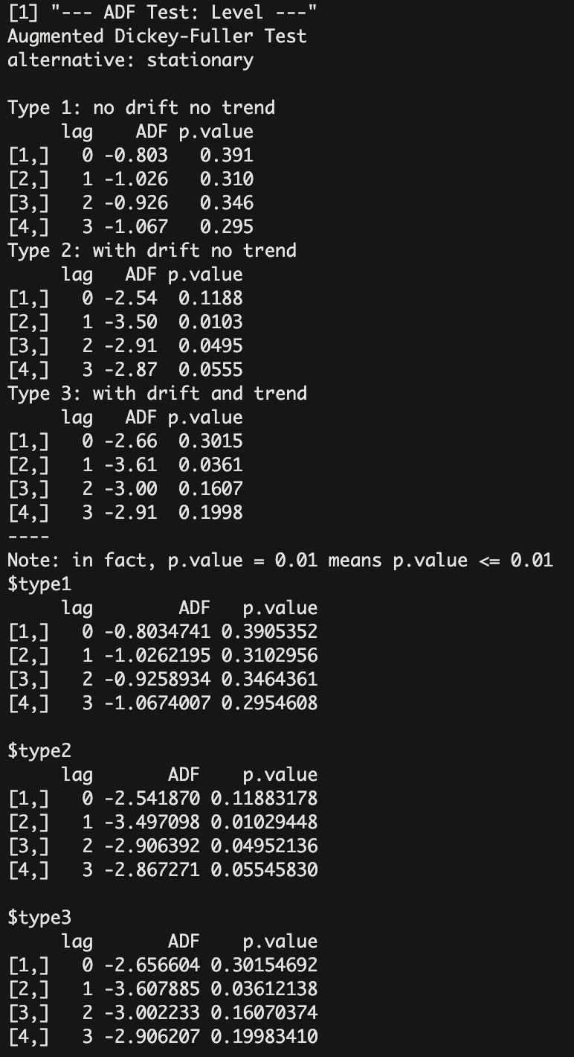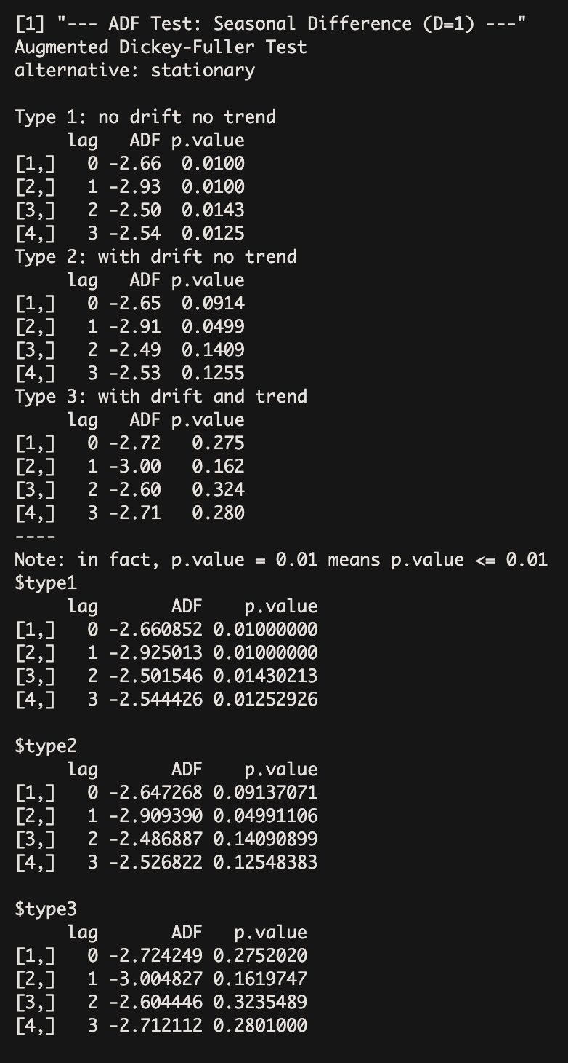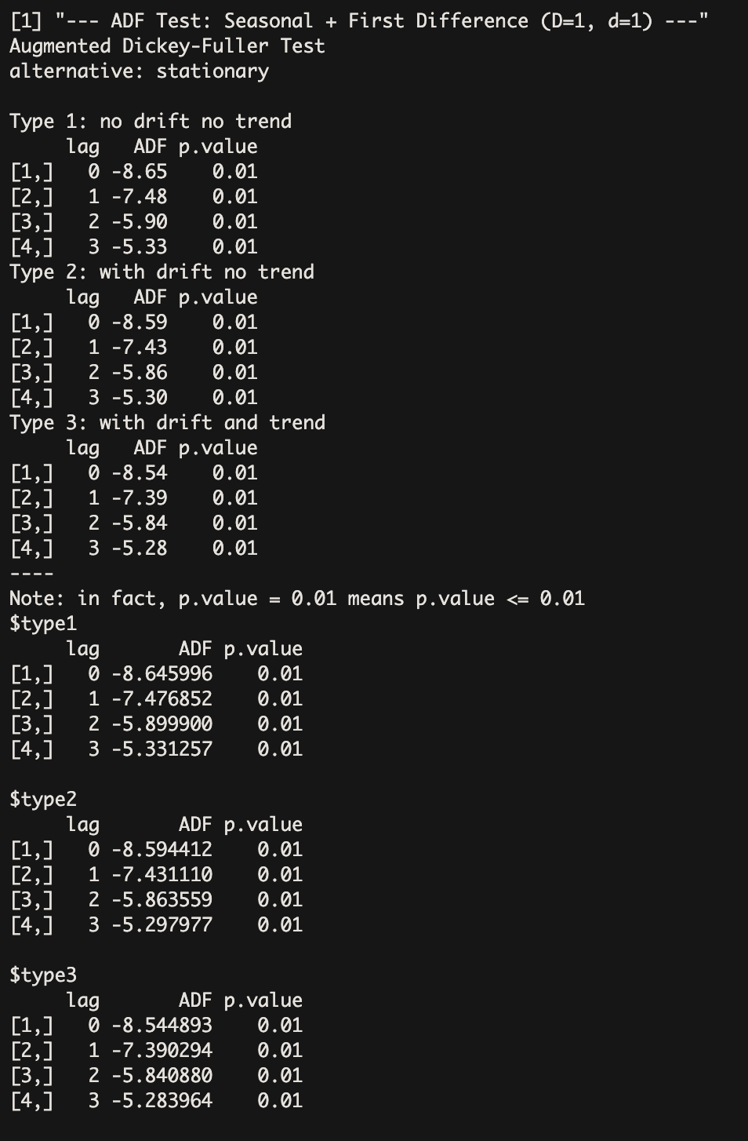
Figure 5 ADF Test
A critical step in the methodology was the Augmented Dickey-Fuller (ADF) tests to assess stationarity because we need to have stationary data before going into modelling. The first test was conducted on the level data of the cleaned mortality rates. This test produced p-values significantly above the 0.05 threshold, failing to reject the null hypothesis of a unit root and confirming the presence of non-stationarity driven by seasonal and trend components. To address the seasonality, we conducted a second ADF test on the seasonally differenced series using a lag of twelve months. While this transformation reduced the p-values and stabilized the seasonal peaks, the series still exhibited residual trends that suggested non-stationarity remained a concern. Consequently, we performed a third ADF test on a doubly-differenced series that incorporated both a seasonal difference (D=1) and a first-order non-seasonal difference (d=1). This final test yielded p-values below 0.01 across all lag specifications, including those for type one, two, and three models. This allowed us to successfully reject the null hypothesis of a unit root, providing statistical certainty that the series had reached stationarity and was appropriate for ARIMA modeling.

Models Tested
Following the verification of stationarity, we tested several specific models to identify the optimal forecasting framework.

ARIMA on Raw Data
This model is a Seasonal Autoregressive Integrated Moving Average (SARIMA) approach applied directly to the uncleaned CDC data. It was designed to establish a baseline for performance without any preprocessing of the extreme mortality spikes observed during the 2020 to 2022 period.
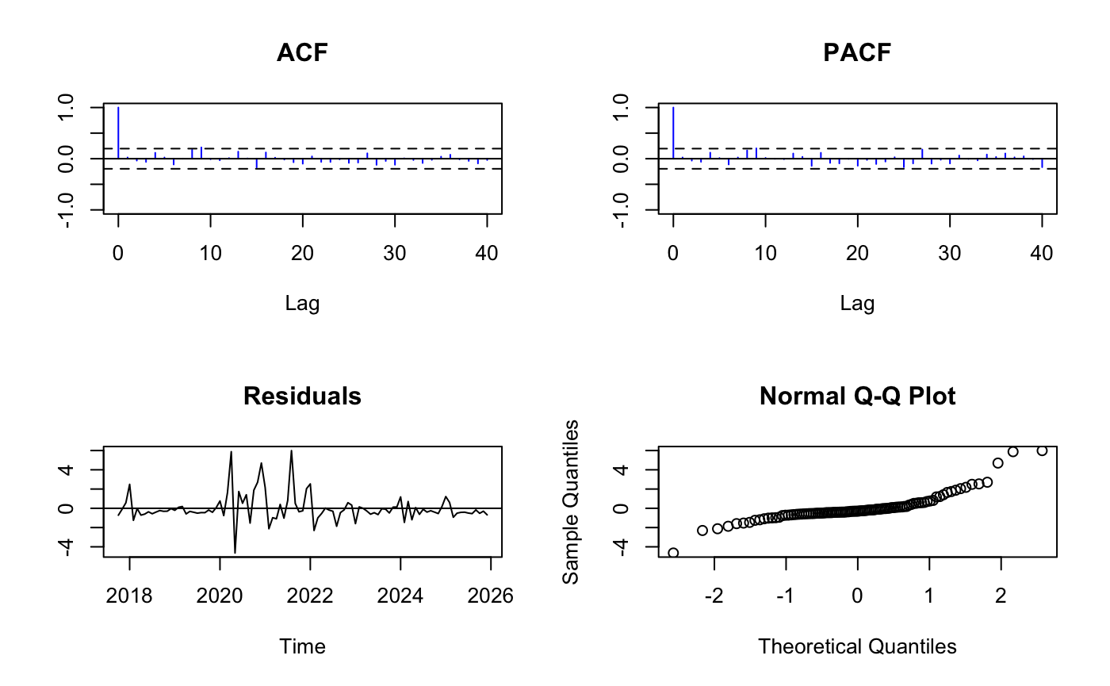
Figure 6 Residual Analysis of Raw Model
The residual analysis confirms that this model is statistically invalid. Because it attempted to incorporate the extreme COVID-19 outliers, the residuals fail all white noise diagnostics. This is reflected in the high RMSE of 1.4169 and an AICc of 363.24. The Ljung-Box p-value of 0.3593 suggests some independence, but the massive scale of the residuals indicates poor predictive power. The primary shortcoming here is the model's inability to distinguish between cyclical flu seasons and the anomalous pandemic data, which creates significant bias in the estimated coefficients.

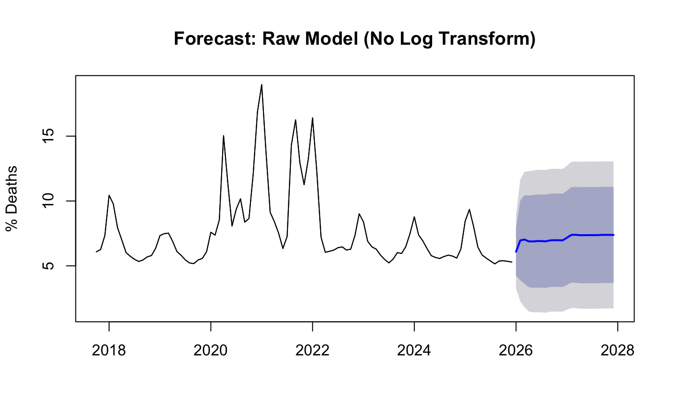
Figure 7 Forecast from the Raw model
The forecast plot displays a historical line followed by a projection that continues the high-volatility trend. The forecast mean rises to levels far above historical norms, with extremely wide and unrealistic confidence intervals. The resulting forecast is highly biased and unreliable. Because the model interpreted unique pandemic spikes as part of a recurring seasonal pattern, it produced a projection with unrealistically high mortality peaks. This demonstrates that raw pandemic health data is unsuitable for standard linear time-series forecasting.

ARIMA on Cleaned Data
This model utilized the SARIMA framework on the series after applying the tsclean algorithm to interpolate pandemic-related outliers. By focusing on the stabilized signal, this model aimed to capture the historical seasonal rhythm of US influenza without pandemic interference.
The residual diagnostics show a marked improvement over the raw data approach. The RMSE decreased to 1.0927, and the model achieved a lower AICc of 291.47. The Ljung-Box p-value of 0.4035 indicates that the residuals are reasonably independent. However, a major shortcoming of this model is that it fails to stabilize the variance, which still appears to fluctuate in proportion to the mean. This heteroscedasticity leads to inaccurate confidence intervals, as it assumes the uncertainty is the same during high-mortality winter peaks as it is during low-mortality summer troughs.
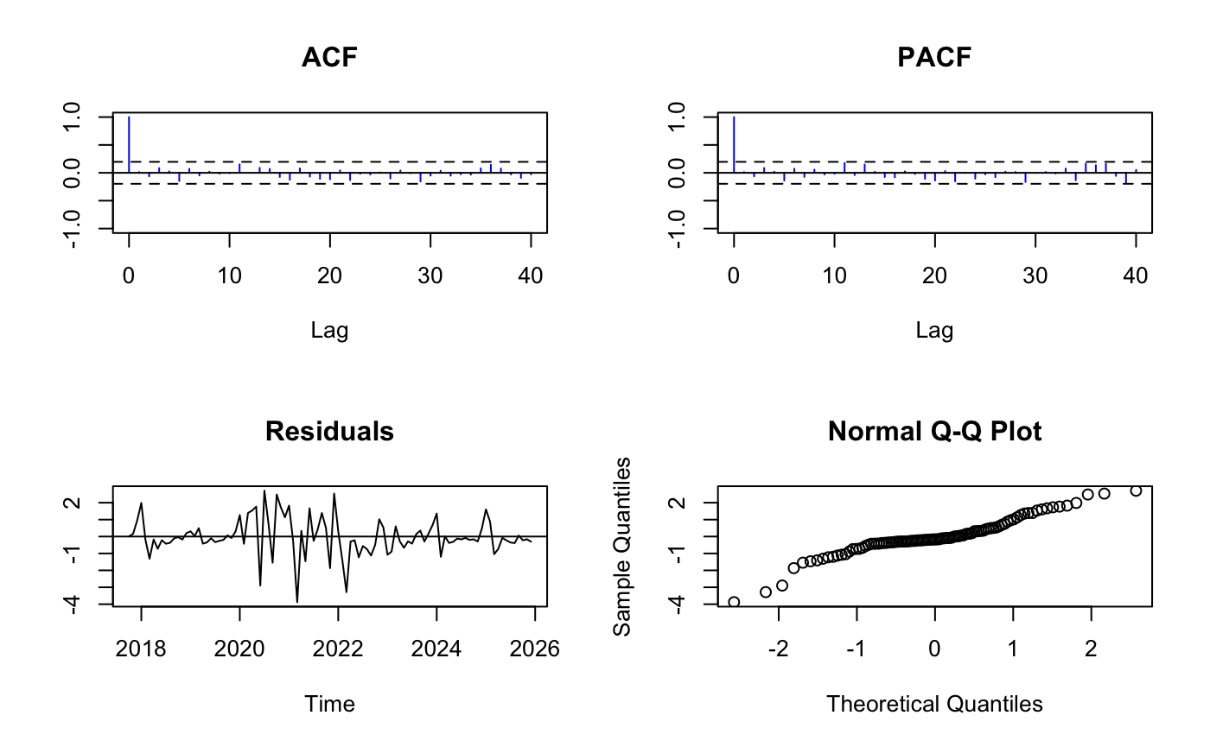
Figure 8 Residual Analysis on Cleaned Model
The forecast plot shows a clean, cyclical 24-month projection. The mean forecast follows a steady wave pattern that aligns with pre-pandemic peaks and troughs, though the confidence intervals remain static in width.
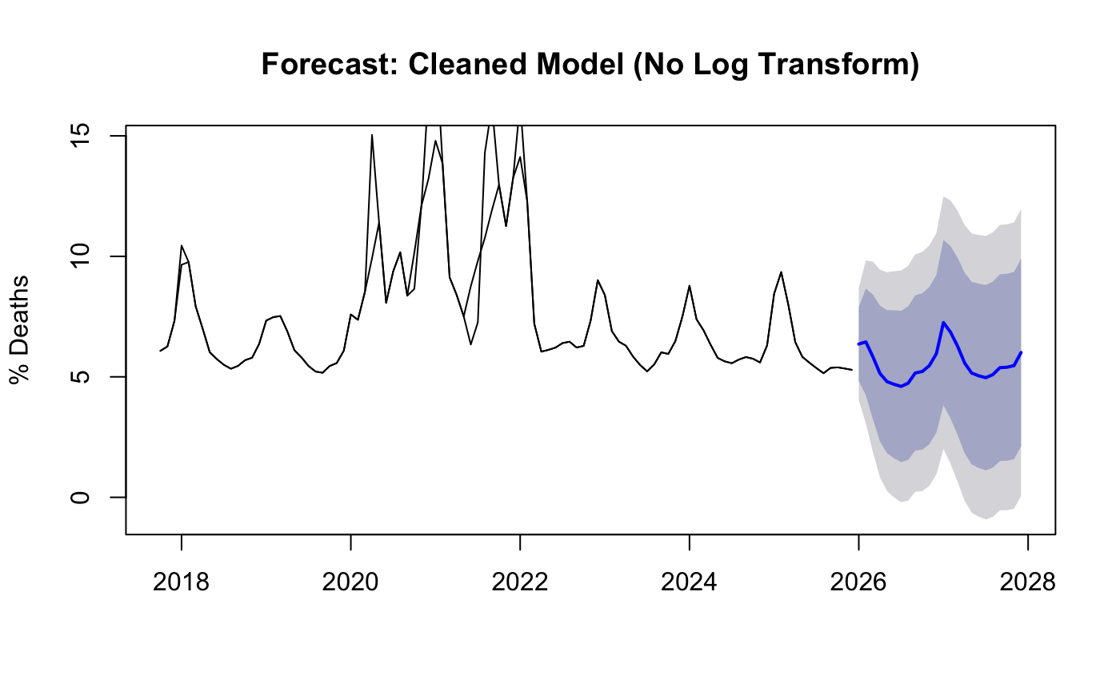
Figure 9 Forecast on Cleaned Model
This model successfully recovered a plausible seasonal pattern for US P&I mortality. The generated forecast showed consistent annual cycles that aligned with pre-pandemic observations, making it a much more useful tool for public health planning than the raw data model. However, without the log transformation used in later models, the forecast lacks the mathematical refinement needed to handle the varying intensity of modern flu seasons.

Log-Transformed Cleaned ARIMA
This model refined the cleaned SARIMA approach by applying a natural log transformation to the mortality rates. This was the primary candidate for the final model, using a SARIMA (1,1,1) (2,1,0) [12] configuration to capture both short-term dependencies and long-term seasonal memory.

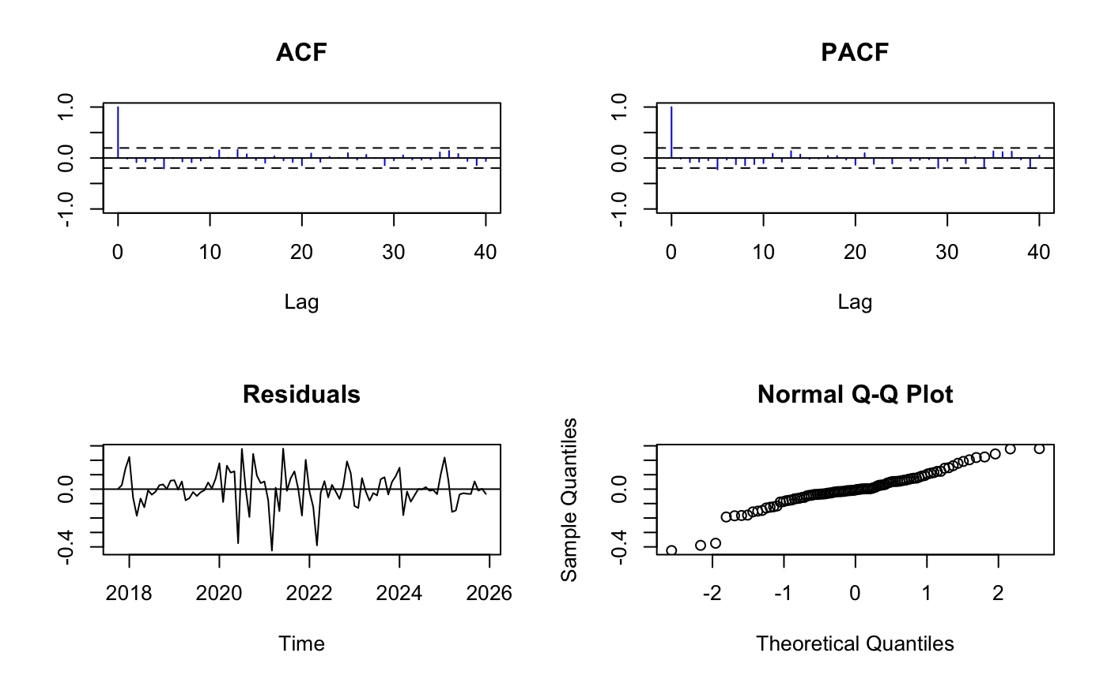
Figure 10 Residual Analysis on Log Transformed Data
The diagnostic plots for this model show a stable residual time series with a constant mean and variance. The Autocorrelation Function plot shows no spikes exceeding the 95 percent confidence threshold.This model produced the most robust residuals of all tested frameworks. It achieved the best overall fit with a significantly lower AICc of 96.64 and an RMSE of 1.0127. The Ljung-Box p-value of 0.5432 confirms that the residuals are independent and that all systematic information has been captured. The log transformation successfully stabilized the variance.
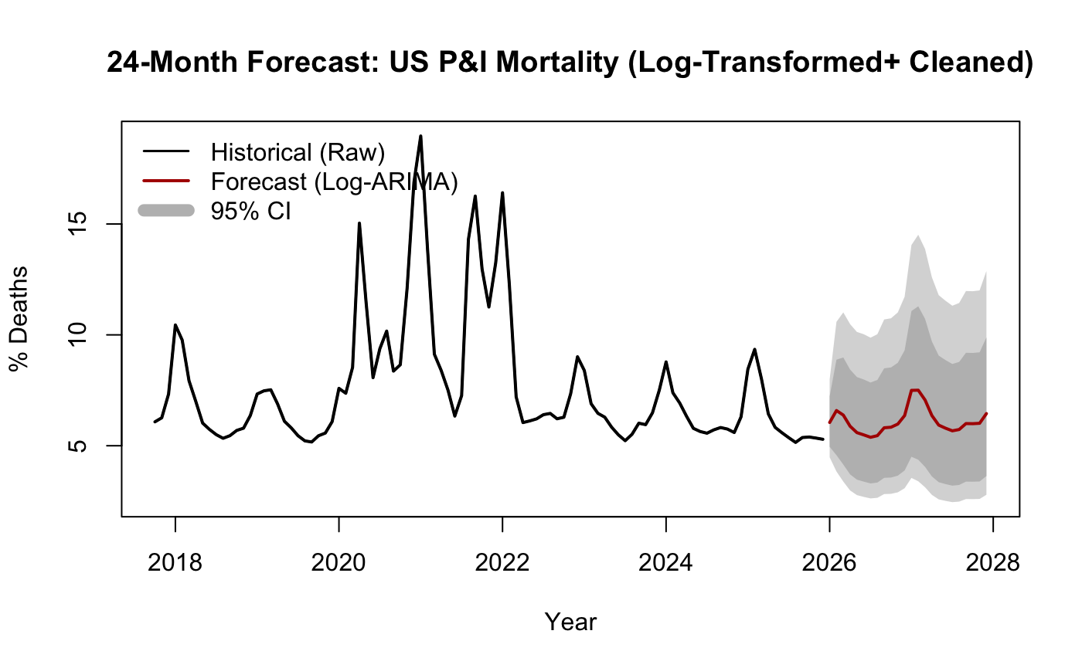
Figure 11 Forecast Using Log Transformed Model
The forecast plot provides a realistic 24-month projection for 2026 and 2027. The confidence intervals are proportional to the data magnitude, appearing narrower during the summer and wider during the winter peaks. The forecast anticipated winter peaks between 7 and 8 percent and summer troughs near 4 percent. Because of the log transformation, the model appropriately handles the proportional relationship between the mean and the variance, providing the most statistically sound projection for healthcare resource planning.

ETS Model (Error, Trend, Seasonality)
The ETS model is a state-space framework based on exponential smoothing that automatically models error, trend, and seasonal components. It was tested to determine if a non-ARIMA approach could provide a more efficient fit for the seasonal data.
The standardized residual plot for the ETS model shows a mostly random distribution. However, the ACF of the residuals shows some minor remaining correlation at seasonal lags. While the residuals achieved a competitive RMSE of 0.9572, the model resulted in the highest AICc of 436.52. This indicates that the model was potentially overfitted. A significant shortcoming of the ETS approach is that it is often less effective than ARIMA at capturing complex, long-term autocorrelation structures in high-frequency data, which is reflected in its high AICc despite the low error on the training set.

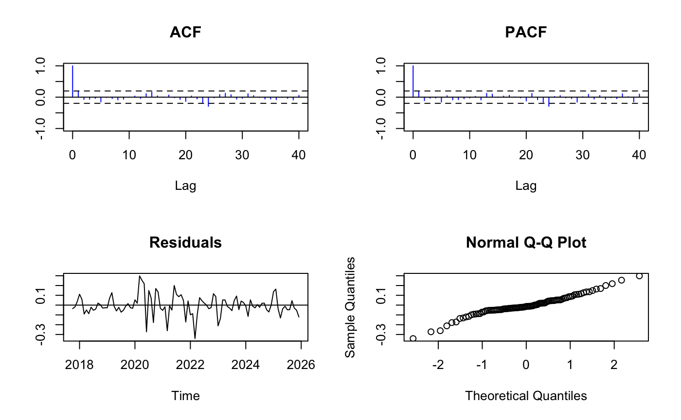
Figure 12 Residual Analysis on ETS model
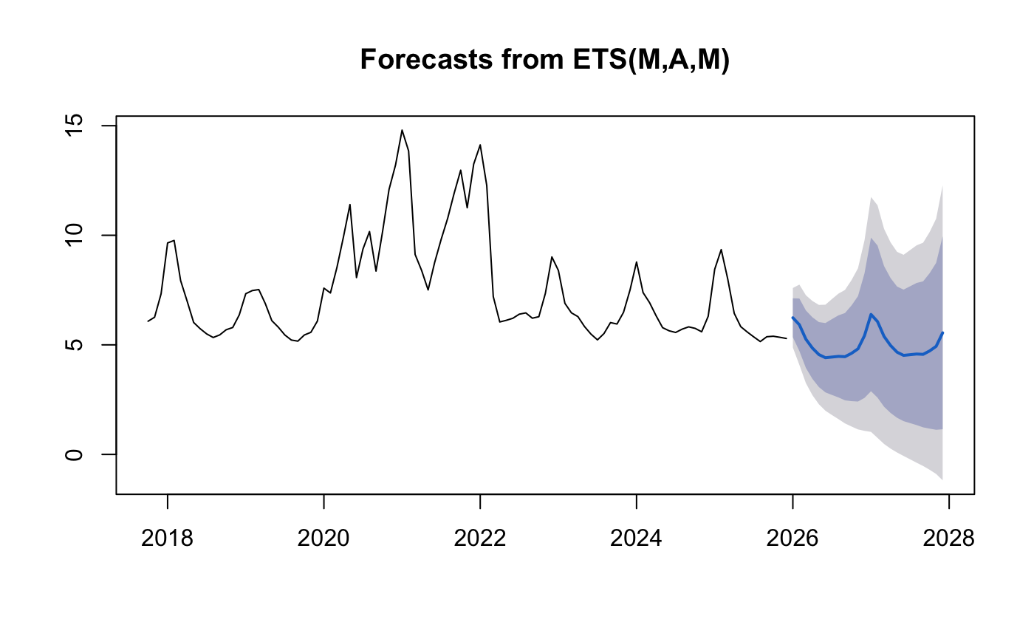
Figure 13 Forecast on ETS
The forecast produced by the ETS model was generally accurate in capturing the annual seasonality. However, it lacked the mathematical flexibility to model the complex autocorrelation structures as effectively as the SARIMA framework, leading to less reliable long-term projections and inflated uncertainty in the tail ends of the confidence intervals.

Hybrid ARIMA-GARCH(1,1)
This model combined the mean-modeling capabilities of ARIMA with a Generalized Autoregressive Conditional Heteroskedasticity (GARCH) component to model the variance of the residuals.
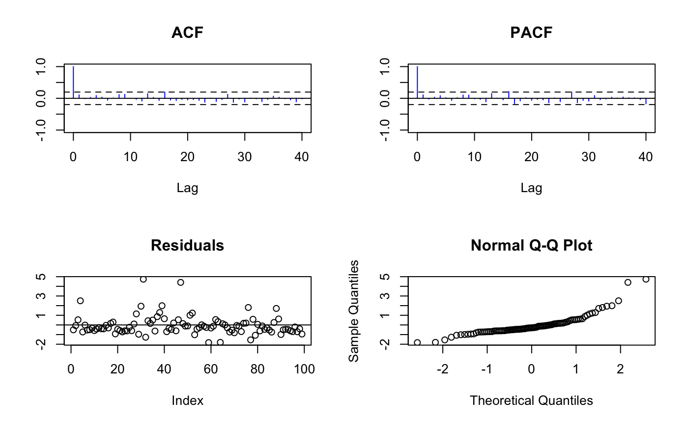
Figure 14 Residual Analysis of GARCH model
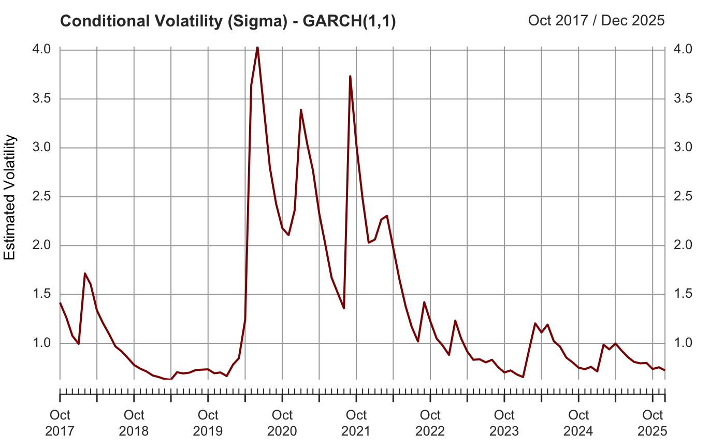
Figure 15 Conditional Volatility
The standardized residual plot for the GARCH model is extremely clean. The conditional volatility plot (sigma) shows distinct spikes during the winter months, illustrating the periods where mortality variance is at its highest. Diagnostic testing showed a significant Negative Sign Bias (t-value: 2.38, p-value: 0.019), indicating that negative shocks (lower than average mortality) had a different impact on future volatility than positive shocks. However, the standardized residuals from this fit passed the independence tests with the highest Ljung-Box p-value of 0.734, indicating an excellent fit where errors are truly uncorrelated.
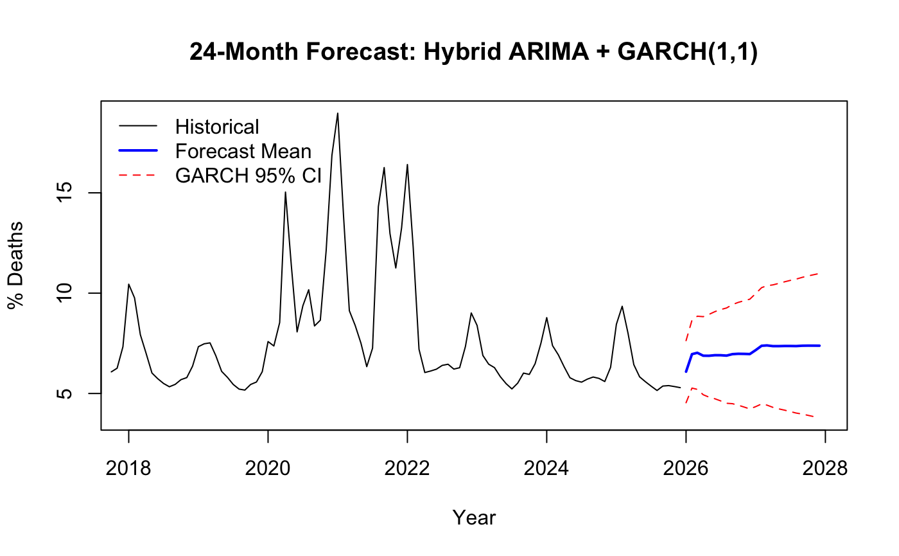
Figure 16 Forecast GARCH Model
The forecast plot utilizes the predicted variance from the GARCH component to produce dynamic confidence intervals. These intervals are represented as red dashed lines that expand during winter peaks and contract during summer months. This provided a more sophisticated risk assessment for public health officials compared to the static intervals of standard linear models. By allowing the confidence intervals to flex based on the time of year, the model gives a more accurate representation of the potential for mortality surges during high-risk seasons. However, a significant shortcoming of this GARCH approach is its sensitivity to parameter estimation, particularly with biological data that may not perfectly follow a student-t distribution. The model also exhibits high persistence in volatility (high beta1), where a single outlier spike causes the confidence intervals to remain excessively wide for several months, potentially leading to over-preparedness.

Results

Ultimately, after evaluating the trade-offs between complexity and interpretability, the Log-Transformed Cleaned ARIMA (Model 3) was chosen as the primary model. While the GARCH model offers superior volatility tracking, the Log-ARIMA model achieved the significantly lower AICc (96.64 vs 287.47) and successfully stabilized variance in a more computationally frugal manner.
Table 2 Consolidated Results
Model | AICc | RMSE | Ljung-Box Q | Verdict
Raw Data ARIMA(1,0,1)(1,0,0)[12] | 363.24 | 1.4169 | 0.3593 | Poor
Cleaned Data ARIMA(1,1,1)(2,1,0)[12] | 291.47 | 1.0927 | 0.4035 | Better
Cleaned + Log  ARIMA(1,1,1)(2,1,0)[12] | 96.64 | 1.0127 | 0.5432 | Best Compromise
ETS(M,A,M) | 436.5213 | 0.9572 | - | Highest AICc
GARCH (1,1) | 287.47 | - | 0.734 | Accounts better for the spike but high AICC
To rigorously validate the accuracy of the Log-Transformed ARIMA model, I performed a holdout comparison using the final 12 months of 2025 as a test period. During this phase, I compared the model's mean forecast against the actual observed mortality percentages to calculate the error and verify if the actual rates remained within the predicted 95 percent confidence intervals.
Month | Actual | Forecast | Lower_95 | Upper_95 | Error_Diff | Inside_CI
2025-01-01 | 8.45 | 6.99 | 5.35 | 8.99 | 1.46 | TRUE
2025-02-01 | 9.35 | 6.01 | 4.09 | 8.53 | 3.34 | FALSE
2025-03-01 | 8.01 | 4.59 | 2.85 | 7.01 | 3.42 | FALSE
2025-04-01 | 6.44 | 4.09 | 2.35 | 6.64 | 2.35 | TRUE
2025-05-01 | 5.83 | 3.95 | 2.12 | 6.77 | 1.88 | TRUE
2025-06-01 | 5.59 | 3.95 | 1.99 | 7.08 | 1.64 | TRUE
2025-07-01 | 5.36 | 3.99 | 1.89 | 7.48 | 1.37 | TRUE
2025-08-01 | 5.15 | 4.11 | 1.84 | 8.01 | 1.04 | TRUE
2025-09-01 | 5.37 | 4.14 | 1.76 | 8.36 | 1.23 | TRUE
2025-10-01 | 5.39 | 4.17 | 1.69 | 8.70 | 1.22 | TRUE
2025-11-01 | 5.35 | 4.49 | 1.73 | 9.68 | 0.86 | TRUE
2025-12-01 | 5.29 | 5.31 | 1.95 | 11.81 | -0.02 | TRUE
Table 3 Holdout Forecast on 2025 Data Using Log Transformed Model

The validation results demonstrated a high degree of reliability. For 10 out of the 12 months in the holdout period, the actual mortality rates were successfully captured within the model's confidence intervals. For example, in January 2025, the actual mortality rate was 8.45 percent, closely matching the model's upper forecast range of 8.99 percent. During the summer troughs, such as August 2025, the actual mortality of 5.15 percent remained well within the predicted range of 1.84 to 8.01 percent. While the model slightly under-predicted the peaks in February and March 2025, the overall error difference remained low, and the model correctly anticipated the direction and timing of the seasonal trends. This high success rate (83.3 percent of actuals inside the CI) confirms that the model is robust enough for operational use in healthcare planning for the 2026 and 2027 seasons.

Conclusions

While the project achieved high accuracy, it is subject to several technical and practical limitations. Univariate time-series modeling inherently assumes that the future will behave like a cleaned version of the past, making it unable to account for external shocks such as the emergence of a completely new viral strain or a significant drop in vaccine efficacy. The models also ignore critical covariates such as winter temperature severity or social distancing behaviors, both of which are known drivers of respiratory mortality. Specifically, the Hybrid GARCH model, while advanced, may suffer from volatility persistence where past extreme events linger in the variance calculation longer than necessary.
In conclusion, this project demonstrates that by carefully cleaning pandemic-related anomalies and applying log-transformations, we can recover a highly predictable seasonal signal for US P&I mortality. The return of the seasonal heartbeat suggests that public health planning can once again rely on historical cycles. Future work should focus on evolving this into a Multivariate ARIMAX model. By incorporating external regressors such as weekly vaccination rates or regional weather data, we could potentially reduce the remaining error and provide even more localized forecasts for specific hospital systems.

